# Personality robot

## Brief description of the problem:

During an era where humans lack social interaction due to the pandemic, emotional support is needed more than ever. However, everyone is keeping busy all the time to adjust to the new lifestyle, so human interaction through social media may not always be the sole solution to help with everyone’s emotional support. Hence, this is the problem we want to solve with our final project.

## Preliminary ideas

We decided to solve this problem by using the Lego Robot Mindstorm EV3 to build a personality bot. We want to give the robot the ability to respond uniquely (like a friend); therefore, it can detect if the owner interacts with the robot and will respond accordingly. The owner is the person with the beacon.

Here are some preliminary ideas our group wants to accomplish in response to the personality. If the robot is:

Happy: The action will happen when the robot spots the owner. It will greet and wave by using motor B. On motor B, we will embed something interesting onto the robot.

Angry: Its IR sensor locks the owner, and the robot will hit the beacon holder. If the robot somehow hits the wall before touching the beacon, the robot will enter a sad state.

Energetic: When it spots the owner using the beacon, the robot will power up its motion motor. It will do some random motion three times with exciting jittery. After that, the robot will accelerate toward us.

Sad: The robot will be (depressingly) moving back and forth by hitting the wall, and after no attention from the user, it will turn around. It will then go to sleep until the owner interacts with it.

Tired: The robot will be slowing down after being on for so long. After a few seconds of a warning message, the robot will turn off.

Confused: The robot will look around and slowly move backwards as a way of showing a state of confusion.

All our robot emotions will have a display on the screen to indicate which emotion it expresses.

## Use of motors and sensors

The use of motors will exist for performing any motion by the robot. We will follow the standard set up with our left and right motion wheel on the ports A and D. On top of this, port B will be used for the third motor. The main purpose of this motor is acting as the moving arm of the robot. It will accordingly perform any distinct action that the robot may need to. For example, the robot may wave to the user when the user is within proximity.

The four inputs that we may use would include the accelerometer, the IR sensor beacon combo, touch sensor and motor encoder values.

We currently expect to use the accelerometer to output different directional acceleration values to differentiate between a nudge, a push, and any other motion. We will further use this to calculate the direction of the incoming forces.

We will be using the IR sensor and beacons sensor combo to notify the robot of the owner’s location. Using the beacon mode of the two sensors, we can receive the general proximity of the user within 100cm of the robot. This includes a relative distance and the general heading between the IR sensor and beacon. This allows the robot to not only track the location, but to react accordingly to some movements performed by the owner.

The purpose of the touch sensor is to indicate when the robot may have bumped into an obstacle. Along with other sensor values we can use this to activate different reactions based on what may be expected at that point in time. For example, if the touch sensor is activated along with the beacon distance being less then a few centimeters, we can assume that the robot has in fact bumped into the owner. Using this we can differentiate between numerous circumstances making the robot a lot more versatile.

Finally, we will use the encoders on the motion motors to track the total distance that the robot has traveled and to calculate degrees turned. One way that this may come in handy is to activate a state of fatigue once the robot has traveled over a certain distance.

## Ideas that may require approval

One idea that we assume may require approval would be our use of the beacon and IR sensor. According to its description, the IR sensor and Beacon combo will report the general distance between the two up to 100cm and using the IR sensor as the base point, we can report the heading between the two for up to 25 degrees on either side [1]. We want to use this to allow the robot to follow the owner as they slowly move around the room. While it may seem plausible on paper, we are still unsure whether the beacon and IR sensor will be able to keep up with what we want it to achieve.

## Additional Parts

The additional parts that will be required to make the robot successful are an EV3 IR sensor and beacon and an Accelerometer

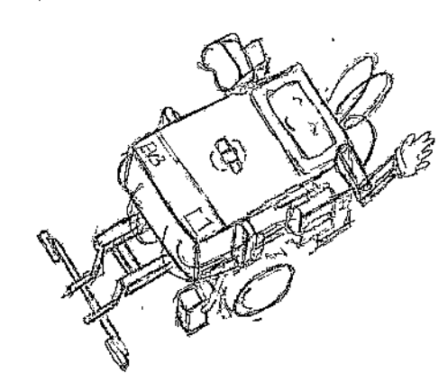

# References

|  |  |
| --- | --- |
| [1] | J. Burfoot, "EV3 Sensors," LEGO Engineering, 30 March 2020. [Online]. Available: http://www.legoengineering.com/ev3-sensors/. [Accessed 5 November 2021]. |